

**The IT World**

**COSC2083 – Intro to IT**

**Lecturer**: Nguyen Minh Long

**Group**: THKT

**Date**: 19/12/2021

Contents

**I. Team Profile** 2

**II. Tools** 12

**III. IT Work:** 13

**a) Data analyst** 13

**IV. IT Technologies** 22

Autonomous vehicles 22

Virtual Reality 25

Cloud Computing 28

Artificial Intelligent 31

**V. Project Ideas:** 34

**VI. Feedback** 36

**VII. REFERENCE** 39

**I. Team Profile**

1. Personal information

a. Ha Viet Bui - s3928433

My nationality is Vietnam and I’m living in Ho Chi Minh City. About my education, I graduated from Tran Khai Nguyen high school and am currently a first-year student of RMIT University. I am passionate about learning languages. Besides Vietnamese, I can speak English and a little Japanese. In my leisure time, I always sharpen my skills in calisthenic exercises, guitar playing, basketball,…. In addition, I’m an extrovert, I am always willing to talk with strangers. As for my hobbies, playing and sleeping with stuffed-animals have been parts of my life since I was a kid, until now, although being an 18-years old teenager, I still have them around me whenever I sleep. Researching Japanese culture is also one of my favorite things to do to let off steam. When referring to Information Technology, I will definitely think about Virtual Reality and Artificial Intelligence, those are factors making me want to study more about the world of IT. Honestly, I don’t really have any experience about AI or even programming skills, I'm a green student in this field. Nevertheless, I strongly believe that I have the ability to absorb new knowledge, accommodate what the job needs and most important is the passion I have with me during my journey to succeed.

1. Nam Thai Tran - s3891890

I was born and raised in Vinh Phuc province, Vietnam, thus my mother tongue is Vietnamese. I am also fluent in English since I have attended high school and college for 3 years in Canada. I went to Woodbridge College (high school) for 2 years and Ryerson University for a year before I headed back to Vietnam due to the COVID-19 outbreak. My hobby is a bit unique to everybody else. I have a hobby of collecting and modifying custom mechanical keyboards. Typing on a normal membrane keyboard for a long period leads to finger fatigue and it is not a pleasant experience. My field of interest in IT is data and A.I technology. I learned to write simple C++ code to send output “Hello + name” with name as an input. Since then, I do not have any particular IT achievement, but I always have programming as my side hobby.

1. Tri Minh Tang - s3927579

Vietnam is my nationality, and I’m currently living and studying in the city named after Uncle Ho. From first grade to grade tenth, I studied in Vietnam, but I went abroad to seek a new education which then graduated from Ben Lippen School. As for fluency in languages, English is the most fluent one, after the mother tongue, Vietnamese, then comes Japanese. I love reading books, self-studying other areas aside from IT, and playing sports with friends in my pastime. One interesting fact about me is that I’d love to advance my knowledge in the psychology field and others’ emotions and behaviours. It excites me as I understand the reason behind someone’s actions. As I take a trip down to the memory land, dystopia movies and pc games pop out. At that time, the little me was excited with the scenes where supreme robots ruled over humanity and how the future was shaped. I started to delve into the IT world more as I grew older. To satisfy my creativity, photoshop and making 3D animations were my first steps. After that, I have been learning how to code, for example, Python and Java. In the future, I would love to create my own program where psychology and computer science can cross over.

1. Khoa Dang Vo Nguyen - s3929602

I was born in Ho Chi Minh City on 19th of August 2003. Being raised as a middle child in a middle-class family has taught me numerous valuable lessons, one of which is to always be curious. My parents told me to always be curious, to ask questions, to try out new things because that’s how we learn new things every day. They also taught me not only to take good care of my mental – hygiene but also to nourish my physical health. Therefore, I tend to participate in sports events, especially at the basketball court and the gym. I also played games with my brother in the past. I believe that I am a hardworking and energetic person, hence it is quite suitable for the IT environment. Since I was a little kid, me and my brother used to play games together. We had an amazing childhood full of joy and laughter. Hence, creating games that would bring people the same experiences we had as children was always my dream. As the technology environment gradually grows, more and more people join the industry which triggers my curiosity in learning about this subject. Coding is the basis in developing a great video game, therefore I believe RMIT is the right university to help me with my first step in achieving my dream. During the course, I expect to acquire the knowledge of the future as well as meeting new people sharing the same hobbies so that we could share the experiences we’ve been through.

1. Team Profile
2. Khoa Dang Vo Nguyen

I’m an Architect (INTJ) as the result from Myers - Briggs personality test given out. According to the description of “16 Personalities”, an architect is a person with the Introverted, Intuitive, Thinking, and Judging personality traits. Accurately, tacticians like me love perfecting the details of life, applying creativity and rationality to everything that I do. Moreover, my inner world is often private and complex. Moving onto the “Learning Style” test, it describes myself as a visual and tactile learner, which is learning by seeing and hands-on projects. For example, chewing gum, walking around, or drawing pictures might innovate my mind and let out some steam while I’m struggling. By doing the third test, team role, I found out that the innovator role suited me best. Instead of getting things done, I prefer to plan out ways to tackle the problem in a most scientific way and contribute ideas in problem solving.

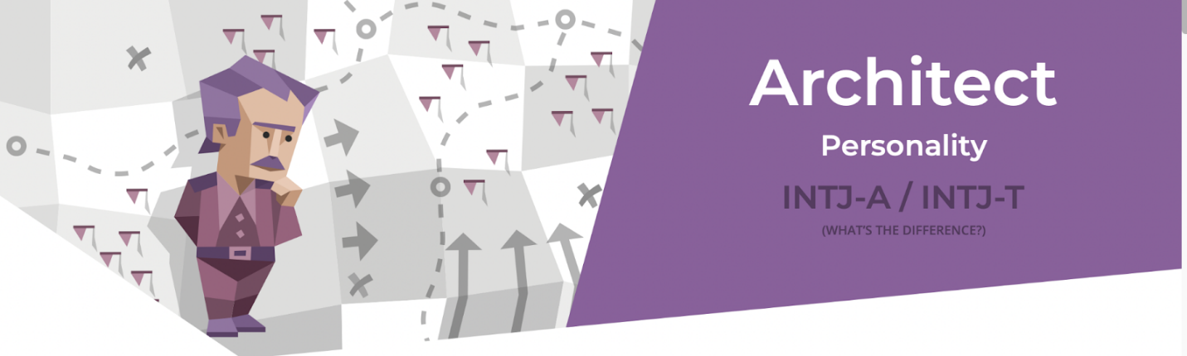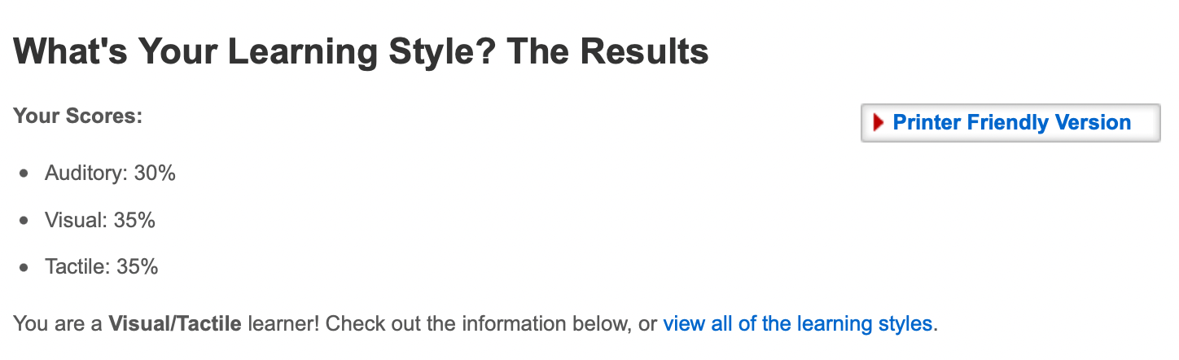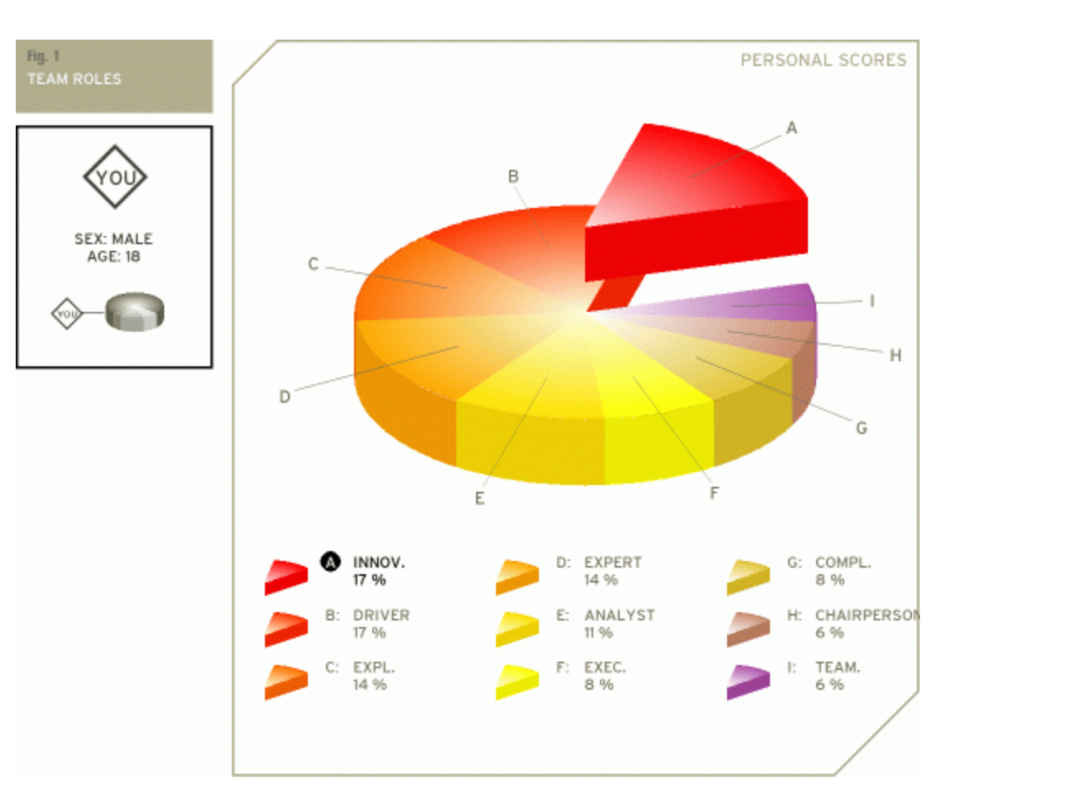

1. Tang Minh Tri

Because of being an Mediator (INFP), I tend to be quiet in a crowded atmosphere, open-minded about most things, and imaginative so I apply a caring, and creative approach to everything I planned out. The possessions of a mediator are Introverted, Intuitive, Feeling, and Prospecting. As a result of having INFP traits, the sensibility affects the way I study effectively. Since I am an auditory and visual scholar, watching processes or listening to the description improves my cognitive skills about the problems, and what I remember about them. If my team ever has to cope with complicated drawbacks, my creativity will come in like a lifejacket. Creativity test specifies myself as a creative person who should specialize in coming up with various ideas, then let other people implement it.

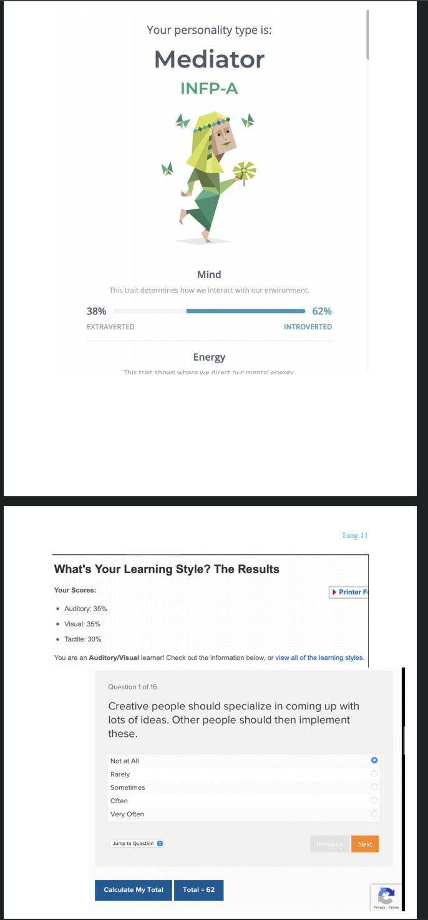

1. Ha Viet Bui

The tests show that I am a hard-working, creative, energetic and kind person. Honestly, I declare myself as a helpful person as I can always give support to people who need it; since high school, I usually took lots of work when doing a project with my team so that everyone can have the relaxation while working with me. Furthermore, it is indicated in the result that I am an extrovert, which means that I am a talkative person, but still acquire the listening sharing skills.

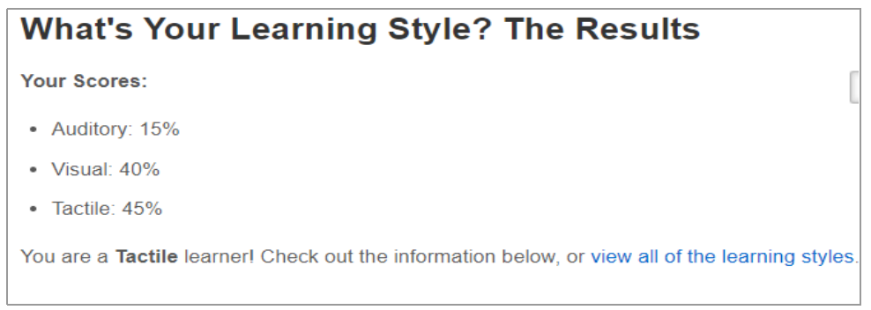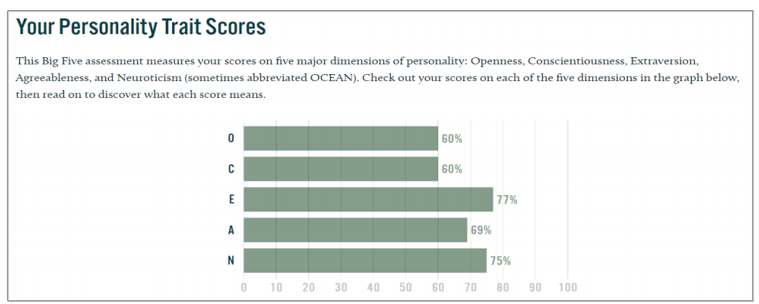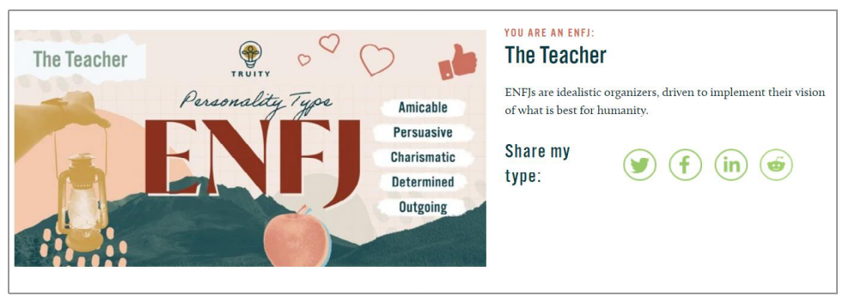

1. Nam Thai Tran

Educationplanner’s test concludes that I am a visual learner. This helps me find the most

efficient method of study. The site also suggests some methods of studying for the visual learner such as: using flashcards, visualizing things when hearing or reading about them. Based on the test’s results, I think I will be able to perform well with a small team. Although the Myer-Briggs test shows that I am an introvert, the Big Five Personality test shows that I am also high on agreeableness and openness. I might not be the one suitable for roles like presenter or working in a large group, but I am open to new and different ideas from other group members.

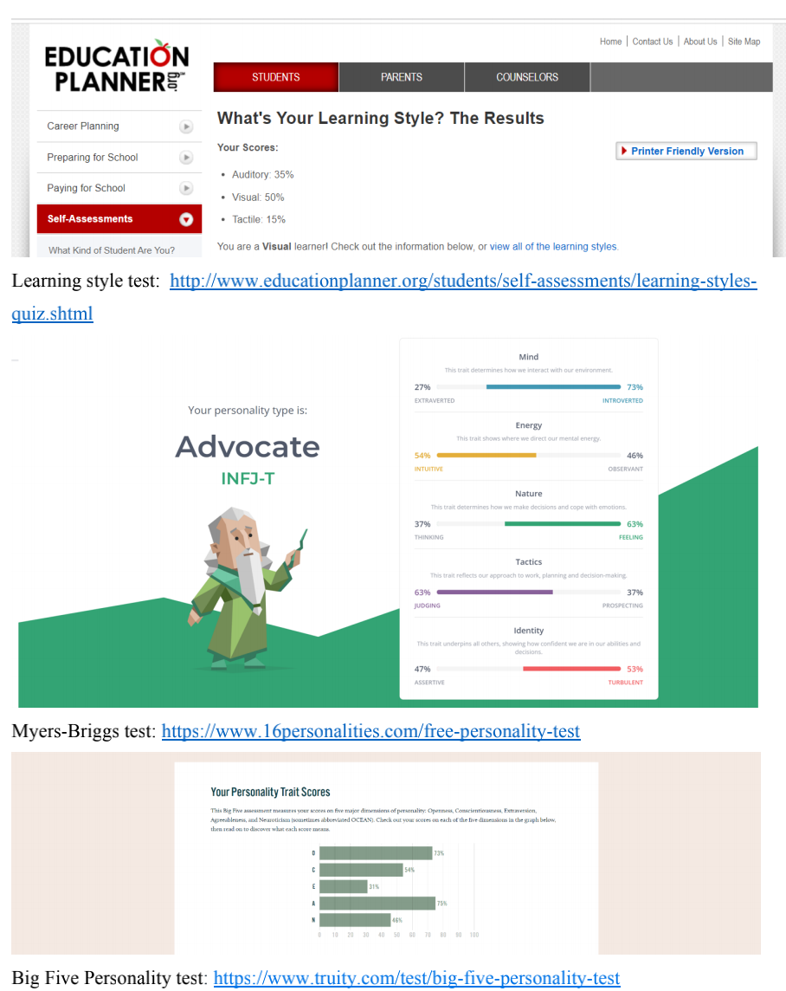

1. Ideal Jobs

Our members have diverse ideal jobs in the IT world. Ha destined to be an AI Engineer after his graduation at RMIT, while Khoa fell in love with Game Development since he was a little kid. Another examples are Tri and Khoa, who chose their career paths as Python Developer and Data Analysis. We both have in common that our IT plans are hot potatoes currently and in the near future, or related to AI. To enhance the graphics for gaming products, companies such as Nvidia, Intel, and AMD have to pour their resources in AI, which improve their graphic cards and vice versa. As a result, the field that Khoa will be working in is going to need AI Engineer like Ha Viet Bui. Moreover, data analysis can’t be left out because of their effort in collecting and analyzing data to use for game industry, and further development of AI. With the need of mastering Python, Tri’s career also play a crucial role. In the 4.0 industry, Python earns its place highly for the versatility and how well-suited with AI or machine learning.

On the other hand, THKT ideal jobs can be categorized into two main parts: creative and analytical. AI engineer and Data analysis aim mainly at working with Big Data and Artificial Intelligent. While, Game or Python dev tend to be creative as we have to come up with new ideas for functions, games, user interfaces, …

**II. Tools**

Working on this project, we have used a lot of tools and applications

Group website: <https://klenathan.github.io/thtkgroupassignment>

Group Github repo: <https://github.com/klenathan/thtkgroupassignment>

(Your comments on how well the audit trail on the Git repository reflects your group’s work)

We used a lot of Mr. Long's recommended tools while working on this project. Our preferred text editor is Google Docs. We primarily used Google Docs for draft editing because it works in real-time, reducing the amount of time it takes to share files. Running in real-time also helps us during pandemics because we can mostly discuss and edit online without having to meet face-to-face. Working online necessitates some form of communication, and we use Meta Messenger and Discord to do so. We usually communicate via Messenger because it is popular among Vietnamese and we all have access to it. We used Discord, a real-time communication app similar to Skype, to discuss problems that are difficult to communicate through text, such as web UI, layout, text-decoration, and so on. Atom and Visual Studio Code are our go-to code editors when working on the website. Both code editors are well-known among developers, but Atom has a slight advantage in that it is easier to learn for beginners. VS Code, on the other hand, supports more plug-ins, which helps speed up the development process. The website was built using HTML, CSS, and JavaScript. Without the use of any external libraries, our website is made entirely of plain HTML, CSS, and JavaScript. Finally, for version control and web hosting, we used GitHub. GitHub version control saved us once when we had some minor errors and bugs during the development process. We used GitHub to host our website, which you can find at https://klenathan.github.io/thtkgroupassignment. Because we used GitHub's free web hosting service, it can take up to 10-15 minutes for GitHub to initialize our code after we upload it.

# 

**III. IT Work:**

**a) Data analyst**

Sources:

<https://www.youtube.com/watch?v=r0vLQvJ3piE>

<https://www.youtube.com/watch?v=ywZXpfdqg1o>

**1. Works:**

-        Define the problems:

o Determine the requirements whether they are dashboard, product analyst or reports

o Create a plan

o Communicate with the team

-        Collect data:

o Data is gathered from many sources. (Database backups, flat files, APIs)

o Create an ETL procedure with the help of a coder. (Extract, Transform, Load)

o Standardizing data and putting it all together.

-        Clean data:

o Since data is always messy, clean data makes data now easier to handle

o Normalize and standardize data

o Validation of data (check whether data looks like what they supposed to be)

-        Set data up for reports/visualization:

o Create views

o Format data for its purpose

o Filter data to narrow down your requirements.

-        Create reports/visualization:

o Automate reports in SQL

o Connect data to data visualization tools (Or Python/R)

o Make sure your reports/visualization meet the clients’ requirements.

**2.      People IT professionals meet:**

-        It can be assumed that depends on the specific profession, the IT professionals would have different kind of people to interact with.

-        Assuming we are talking about professions that require spending time on the computer then the answer would be colleagues and clients.

-        Otherwise, professions that require knowledge about IT can meet other people such as investors, or the public.

**3.      IT spend most of their time:**

-        Depends on the specific occupations

-        However, I believe that most of them would spend most of their time at places which are spacious such as at home or at the office.

**4.      Challenges:**

- Skills gap: Since IT professions require an absurd amount of knowledge, IT have to update their knowledge frequently.

**b) Game Developers**

**Sources:**

<https://www.youtube.com/watch?v=V5o6CQNPgsQ>

<https://www.youtube.com/watch?v=k1AWLuFGEAg>

<https://www.youtube.com/watch?v=e_TxH59MclA>

**1.      Works done by Game Developers:**

- Sketching out game concepts with teams:

o        Reassemble a team including: designers, developers, marketers/publisher

o       Discuss about the game concepts with the team: storylines, scripts, arts, characters.

o       Searching for investors for budget (if needed)

- Documenting every step of the game development process:

o        Easily update data and fix errors when problems arise

o        Help other developers to keep track on the game development

- Designing games:

o        Game developers utilize computer software to create 2D and 3D models of game assets, such as scenery and characters. This covers character animation and the creation of any virtual reality surroundings.

-   Code writing:

o        Using suitable programming languages to code for the game’s logic and features

-   Debugging and testing:

o        Testing and debugging take place both during development and after the game is delivered to the player to assure the game's quality and the user's experience.

-   Maintaining the project:

o       Collecting player’s feedbacks including new features requests, bugs reporting, etc.

o       Enhancing the game: making updates of new levels, characters, etc.

**2.      People Game Developers meet:**

- It depends on what kind of works the Game Developers need to do:

o         For example, if they need to change certain animation elements, they will go to the Designing team for assistance.

o         Usually are the other Developers as they are divided into a specified area by the business to easily exchange information and cooperate.

o        If it is a game launch or demo session, they will be likely to meet clients and investors.

**3.      Places where Game Devs spend time:**

-        These days, there are many Indie (Independent) Game Developers who make games without the financial support of video game manufacturers. Therefore, they can work everywhere: home, computers laboratory, etc.

-         Developers that work for corporations would often work in an office setting to maintain a professional and supportive environment.

**4.      Challenging aspects:**

-        Will likely to experience low motivation: many things to do, stressed and tired.

-        Need to frequently update new knowledge

-        No balance between work and other aspects of life: IT jobs are usually very time-consuming

**c) Cyber Security**

**Sources:**

<https://www.youtube.com/watch?v=uHy3oM7NnoU&t=340s>

<https://www.youtube.com/watch?v=-q0vlBeGqa8>

<https://www.youtube.com/watch?v=yuyVElFHjy8>

**1.      Work is done by Cyber Security Professionals**

-        Checking tickets from managed services contract customers if they auto-resolved

-        Discussing problems with co-workers

-          Proficient in programming (system and network programming knowledge) to create effective security programs

-        Risk analysing: cyber attackers, breaches,etc.

-        Meeting with clients

**2.     People Cyber Security Professionals meet:**

-        Certainly, they will meet their co-workers to discuss about problems solving, reports from SOC team ( Security Operation Center )

-        Besides, they talk to their clients about works (flagged tickets, required tools ,etc.)

-         In addition, self-employed workers can choose to work from home due to their flexible schedules, and they can communicate with their team and clients via phone and online meetings.

**3.      Places where CSP spend time:**

-        Cyber security professionals spend most of their time working on online platforms for information updating, contacting through online meeting applications ( Microsoft Teams, Zooms,etc.)

-        Office is an ideal place to work for the CSP: professional environment, necessary equipments, supportive co-workers, be able to fully focus on working,etc.

-         In addition, as previously stated, they work from home since it is more efficient and convenient: less travel time, more pleasant time schedules (balanced between working and sleeping), and a familiar working environment.

**4.     Challenges aspects:**

-        Always ready to adapt new risks (IoT, AI,Phishing scams, new cyber viruses,etc.) : 5G is gaining traction as a solution to improve the speed and responsiveness of wireless communications. However, new things do not always imply that they will be better, since new threats may emerge. As a result, Cybersecurity Professionals must be prepared to deal with these evolving networks.

**d) General IT Professionals**

**Sources:**

<https://www.youtube.com/watch?v=EZXZy4gWWS0>

<https://www.youtube.com/watch?v=E1qrTc4SyXo>

**1.      Work done by IT professionals:**

- Depend on the jobs that work can be done differently:

o Occupations such as web developer, application developer, game developer require coding in different programming languages

o   Work done by jobs such IT support specialist, IT analyst, IS analyst would be helping people solve their problems and issues

o   Network technician’s, network engineer’s work is to handle VPN and firewall

o   IT director, Chief Information Officer, Director of Technology are going to have lots of meeting

**2.      People IT professionals meet:**

-       Once again, depend on the jobs, different people can be met by IT professional

-        Developers usually have meeting with colleague to discuss about the plans, other than that they are usually on their own

-        Support specialists meet customers and clients daily to help them with their issues

-        Technicians and engineers are quite similar to developers

-        Jobs like IT directors spend most of their time meeting clients or business partners.

**3.      IT spend most of their time:**

-        Developers spend most of their time in the office or at home so that they can fully focus on their work

-        Support specialists spend their time at the office where there is equipment to help them with their support

-        Similar with support specialist, technicians and engineers spend their time at the company

-        CIO, director on the other hand spend their time at meeting points

**4.    Challenges:**

-        Globalization: Companies need to find a way to effectively operate global technology

-        Mobility: Ensure that people can travel safely and securely wherever they need to go using cost-effective communications and capable connectivity.

-        Education: Develop people that can fully understand the industry

**e) Software Engineers**

**Sources:**

​​[A Day in the Life of an Amazon Software Engineer in Washington D.C. (in office)](https://www.youtube.com/watch?v=Qw1ZP5EDZic)

<https://www.youtube.com/watch?v=VQdniD1f6lk>

**1. Works:**

- Work is done by the Software Engineer:

o Checking emails, Slack channels for updates

o Daily team stand up - checking team members’ status

o Thinking about the software design

o Meeting with remote team

o Writing and reviewing the code

o Meeting with clients

**2. People Software Engineers meet:**

- Software Engineers usually meet their team members to discuss ideas, concepts, or how to put in practice.

- They sometimes sit with clients for information about the software requirements and updates.

- Shoppers and waiters are go-to people as they come for lunch. Software engineers have flexible schedule so they do not need to come to the office.

**3. Software Engineers spend most of their time:**

- Most of the times, software engineers spend their time on catching up with the up-to-date information via Slack, Microsoft Team, etc; and reviewing code or actually coding the structure for the software.

- Secondly, their have-to pastime are reading related books, articles

- Sometimes, they have to do researches for team meetings.

**4. Challenges:**

- Immobility: since software developers use most of their working time sitting, they might get obesity or serious health problems if they choose to not working out in the gym or have the healthy diet.

- Communication: doing team stand-up or remote meeting enhance the ability to work in group, but in reality, software developers rarely communicate with others. As a result, anti social syndrome will become a common disease in workplace.

**IV. IT Technologies**

## Autonomous vehicles

**a. What does it do?**

An autonomous vehicle is defined as a vehicle that can drive itself from point A to point B using various technologies and sensors like cruise control, steer by wire, ABS, GPS, etc. Currently, the most advanced self-driving system in the world is the Full Self-Driving Tesla Autopilot. On the base Tesla model, they offer level 2 autonomous vehicles. By definition, a level 2 (hands-off) autonomous vehicle can drive itself under the driver’s supervise. At this level, Tesla claims on their website that:

“Autopilot enables your car to steer, accelerate and brake automatically within its lane.”[1]

This does not sound revolutionary or different from other companies at the first glance since this only means a Tesla can auto lane correct and avoid collisions. The real difference between Tesla and other automotive manufactures lies in the Full Self Driving (FSD) package. In addition to the base Tesla autopilot system, Tesla also offers customers FSD as an upgrade option when purchasing a vehicle. With this package, Tesla tried to achieve level 5 autonomous vehicles, in which the vehicle autonomously drives itself from point A to point B without the need for driver supervision.

“ Full Self-Driving Capability introduces additional features and improves existing functionality to make your car more capable over time including: Navigation on Autopilot, Summon, Autopark, Auto Lane Change.” [1]

Tesla also includes active safety features in all Tesla. This package includes: Automatic Emergency Braking, Forward Collision Warning, Blind Spot Collision Warning, Lane Departure Avoidance. The Automatic Emergency Braking system has saved a lot of lives due to its incredible fast reaction time which humans cannot compare with.

Right now, the automotive industry is trying to catch up with Tesla in self-driving software. Giants like General Motors (GM) and Mercedes are investing big money into developing their own self-driving systems. GM is investing in startups Cruise. Cruise is serving people in San Francisco, in a controlled environment like companies campus, schools, as autonomous taxis for a few years now. They are targeting to have a million autonomous cars by 2030. Mercedes is working with Nvidia on its self-driving system. They already have demos on closed track on their newest self-driving S-class Mercedes. Vietnamese automotive company Vinfast, although they are young compared to other giants, is also developing a self-driving system on their vehicle to fit the needs and conditions of the Vietnamese market.

Autonomous driving technology is thriving thanks to the development of its backbone technology recently: A.I and big data. In recent years, the development of A.I, specifically computer vision has allowed companies like Tesla to develop a state of the autonomous driving system. The development in hardware also accelerates the process. In 2019, Tesla put out their newest generation of computer system, the brain of the vehicle. The computer can perform 36 trillion operations per second, that is 36,000,000,000,000 operations per second [2]. Mercedes is cooperating with Nvidia, a giant in GPU hardware manufacture and A.I technology. Nvidia’s newest generation of GPU can perform 312 trillion operations [3], nearly 8.7 times more than Tesla’s computer. Although the unit is very power-consuming which might not fit for a vehicle, we can see how companies like Nvidia will help accelerate development in autonomous vehicles.

**b) What is the likely impact?**

Autonomous vehicles can bring a lot of benefits to the world. For starters, autonomous cars can cause fewer accidents. Car accidents can be caused by a variety of factors, but the majority of them are caused by human errors like slow reaction time, distraction while driving. These human errors can easily be eliminated with autonomous technology. Furthermore, as the number of consumers rises, the technology became more mature. Tesla collects data from drivers in order to improve their software, and their Vehicle Safety Report is the most conclusive proof. According to the Tesla Vehicle Safety Report [4], in the second quarter of 2021,  in the United States, there was a Tesla accident every 4.41 million miles driven, compared to an accident every 484,000 miles driven on average.

On the other hand, there are some drawbacks autonomous vehicles bring with them. People who make a living by driving cars, trucks, and buses may find themselves out of work if these vehicles begin to drive themselves. According to the United States Bureau of Labor Statistics, over 2.0 million people worked as tractor-trailer truck drivers in 2019 [5]. Taxi and delivery drivers employ 370,400 people, while bus drivers employ over 680,000 people in the United States. Taken together, this amounts to a potential job loss of more than 2.9 million, which is higher than the number of jobs lost during the Great Recession in 2008. When you factor in delivery and light truck drivers, the total number of jobs at risk rises to 4.5 million. It will be difficult for these workers to find new jobs quickly, and the cost of retraining them may be prohibitive.

**c) How will this affect me?**

From my point of view, this change will greatly benefit me in the future. Personally, my dream job is to work as a data scientist, and with the current rate of development, there will be plenty of job opportunities for me in the future. Vietnam is a thriving country in technology, I believe in the future, there will be more Vietnamese technology companies and startups working in this field. Apart from jobs, an autonomous vehicle would be extremely beneficial to me and my family. In Vietnamese culture, consuming alcohol is hard to avoid during special events like Tet Holiday or family gatherings. It would be dangerous if the driver is intoxicated and driving. An autonomous car would protect the driver and their family. People can drink and still get back home safely.

## Virtual Reality

**a)    What does it do?**

As the name tell, VR technology creates simulated environments where users control animated characters with an 360 degree viewing angle. In recent years, many developers are able to simulate as many senses as possible, from vision, hearing to even touching and smelling. However, its content and devices costs are the problems restricting VR’s development. To have this experience, a HMD ( Head-mounted device ) is used, there are many large VR companies who dominating the whole industry: Oculus, Samsung Gear VR, HTC Vive, Google Daydream View, Microsoft,…

Tracking every movement of eyes in HMD can not only be very useful in giving an enormous source of information but also to enhance VR experience. This function can be applied to different fields, but mostly is about what a user/customer is looking at. For instance, VR in fashion industry, customers are given a HMD and immerse into a virtual world where they can easily,freely move and look around in a 3D space. Ofcourse, in the virtual world customers are in, they can visit the store and its products. Therefore, developers and businesses are able to know what products users usually looking at, are they interested or not.

There are different ways to use VR that users around the world love to try, flying for instance. The excitement of flying like birds, insects has motivated mankind for a long time ago. And recently, developers have generated birdlike flying simulator that is far more than just wearing a VR headset. Users will be arranged into flying posture, lying on a bird-shaped apparatus with the headset. Furthermore, VR Technology has been applied in various fields in recent years: Medical, education, military,… By using virtual worlds in specified fields, people can enhance practical skill and learn from their mistakes without afraid of severe consequences. All in all, VR Technology is thriven on a world-wide scale, VR is not just about entertaining purposes but further more than that, it is about integrating reality and virtuality, beyond the limit from the past.

In the next 3 years, people will be able to upgrade hardwares as they are the most essential components when referring to VR. In addition, VR hardware market is hugely noticed and developed by a small number of players, small producers but with innovative ideas & devices, even better than large-brand companies, but they are not well supported and having limited technology resources. Additionally, businesses will reduce cost of materials in order to reach more customers from all levels, moreover, reduce the weight of equipments is also important, it makes the experiences more immersive, more comfortable, more intriguing and realistic. Obviously, for the far future of VR, there are endless applications of this technology. Maybe, in the the next 50 or 100 years, humankind can separate the mind from the original body just like the movie: The Matrix, Avatar. Through computing, leveraging new technologies, we can virtualize every processes in the real world, we can work, learn and contact to each others in real time model.

Still, humankind have a long way to go to actualize those mentioned above. From my perspective, scientists and developers need to create nano-size ( or even smaller ) robots and transfer them into human’s brain at which they can send signal and frequency to connect to computer’s servers. Probably, at that time, digital messages will be transmitted from computer into human brain. Therefore, users can experience every senses, feeling, touching,.. in the virtual world as they are in real world.

**b)    What is the likely impact?**

There will be dramatic change of people’s normal life ! Everything from working,studying, entertaining,.. will be completely different. For working, as mentioned above, there will be virtual training environment for each jobs. Businesses may utilize this technology to improve their employee's experience; for example, workers who perform dangerous tasks will be armed with practical information and will not have to worry about making mistakes. Same for studying purposes, VR technology provides students with a realistic, intelligible, and digestible approach that is far more engaging than books, documentaries, or movies. In this Virtual World, there will be locations appropriate for each topic. For example, in Biology, students and lecturers will be able to view cells, internal organs, and other little details that are not visible to the naked eye. Not only will we be able to save a significant amount of money on laboratories and scientific instruments such as microscopes and telescopes as a result of this, but this strategy will also make lessons more fascinating than ever before, increasing learning efficiency and knowledge memorization. When it comes to who will be impacted, I believe that the younger generation will be the primary target of this technology. Children's learning styles may vary dramatically, both for the better and for the worse, they will view genuine graphics and put what they have learnt into practice during their lessons. On the contrary, if we overuse this technology, user’s eyesight will be most affected by seeing the screen from a too near distance. Personally, I believe that virtual reality technology will eventually replace all office employment; instead of working in a real office, individuals would work in a virtual workplace at home in their animated character while still assuring productivity and efficiency, this will be very new and interesting if it become true !

**c)     How will this affect myself?**

First and foremost, my methods of entertainment will be incredibly intriguing; playing games with hands-on movements will be more realistic, which will, of course, increase my satisfaction as a gamer. Same for communicating purpose, in my opinion, talking and interacting through VR will be great as we can appear in an animated character and have a wander around the virtual world with friends, families,etc. With VR, I can travel around the world, make more foreigner friends and have an insight into different culture from countries. Furthermore, this will helps a lot with my studies, I can access to real images of what I have learnt and be able to practice in specified field, equip myself with solid knowledge base for working in the future. Studying languages will be more efficient because I will be able to readily discover foreigners with whom I can communicate in their languages, and they will be able to assist me in improving my vocabulary, pronunciation, and grammar. My parents will mostly utilize it for job purposes, but they will also be able to experience many new things that their age and physical condition do not permit. To summarize, VR technology has the potential to enhance people's lives in a variety of ways: individuals may enjoy unaffordable experiences without spending money, knowledge will be available in an engaging and effective manner, and people from all over the globe will be able to communicate and become closer.

## Cloud Computing

**a) What does it do?**

In simple terms, it is the distribution of conventional computing services - servers, storage, databases, networking, software, analytics, and intelligence - over the Internet (“the cloud”). Moreover, Cloud computing provides faster innovation with more flexible resources and economies of scale for different size companies.

Since cloud computing changes the way businesses operate, its top benefits are narrowed down into six parts. First of all, the cost of cloud computing is the utmost benefit when companies consider the service. Cloud computing reduces the upfront costs of purchasing hardware and software, as well as the cost of building up and maintaining on-site data centers-server racks, the round-the-clock electricity for power and cooling, and IT specialists to manage the infrastructure. Secondly, computer services over the Internet provide exceptional speed for on-demand computing resources. Most cloud computing service providers give businesses much flexibility and take the pressure off capacity planning in just a few clicks as the vast amounts of resources are provisioned within minutes. The third benefit on the list is its global scale. Cloud computing implies delivering the proper amount of IT resources - for instance, more or less computing power, storage, and bandwidth - at the right time and from the right geographic place. Another advantage to point out is the performance. Most popular cloud computing services are hosted on a global network of secure data centers that are updated on a regular basis with the current generation of fast and efficient computing hardware. As a result, cloud computing has lower application network latency and higher economies of scale. Lastly, many cloud companies provide a comprehensive set of policies, technologies, and controls to help you improve your entire security posture and safeguard your data, apps, and infrastructure from cyber-attacks.

Despite cloud computing satisfaction, its artists remain as 4 broad categories, which are IaaS (infrastructure as a service), PaaS (platform as a service), serverless, and SaaS (software as a service). With IaaS, cloud computing services are in their most basic form. IaaS allows customers to rent IT infrastructure - servers and virtual machines, storage, networks, and operating systems on a pay-as-you-go basis. As for PaaS, cloud computing services provide an on-demand environment for designing, testing, delivering, and maintaining software applications that are referred to as platform as a service. PaaS was created to make it simpler for developers to construct web or mobile apps rapidly without having to worry about setting up or managing the underlying infrastructure of servers, storage, network, and databases.

Looking at the future of cloud computing, gaming industry, multi-cloud or joint cloud provider, and automated cloud orchestration with optimization will play pivotal roles. Even though the cost of home gaming equipment levels off recently, most people's entertainment tastes will change to cloud gaming. As multi-cloud and joint cloud providers are being born, they allow joint customers to migrate and run their enterprise application workloads across various cloud platforms. The complexity of managing both the amount and quality of linked services across apps and services overwhelms even the most savvy IT businesses, cloud platforms will continue to create automated cloud orchestration and optimization.

**b) What is likely be impact?**

With cloud computing's vast potential, it is anticipated to have an influence on a wide range of disciplines. According to my study, the areas where cloud computing has an impact may be divided into four categories: cybersecurity, privacy, the digital business environment, and ICT industries. As cloud computing grows in popularity, security will become more frequent. In the near future, the IT sector will witness an increase in the usage of checklists and security certifications, as more support is put into the creation of open and secure software and hardware, as well as encryption technologies. Professionals may examine the economic viability of big hardware security modules and start a conversation about the Future Internet's structure and governance. The establishment of privacy as a geographical benefit is the second category on the list. Cloud computing advances data protection modernization, supports the establishment of a European Data Protection Board, and ensures the extraterritorial implementation of European data protection legislation. Furthermore, by design, it establishes the concepts of security and privacy. Third, cloud computing has the potential to provide a trustworthy environment for digital commerce and life. For example, it requires the establishment of basic contract standards, supports the standardization of Acceptable Use Policies and Service Level Agreements, eliminates jurisdictional ambiguity, and promotes the development of Cloud-specific certifications. The last affected industry is the ICT industry, where cloud computing has created an exciting environment. It encourages the formation of European market participants, promotes standardization and interoperability, and helps ICT firms reevaluate their current broadband strategy. As a result, many in-house IT roles inside corporate organizations are expected to decline in the future. Some positions, such as System Administrators and Database Administrators, or Help Desk Support, may become obsolete when corporations migrate to the cloud; nonetheless, cloud providers will need these professionals. Experienced IT project managers, enterprises and cloud computing providers, and software developers, on the other side, are expected to witness a surge in demand.

**c) How will this affect me?**

In recent years, the use of cloud computing has shifted our everyday lives to a new page. My life has changed as the cloud computing industry has grown at a rapid rate. For example, recreations such as gaming, watching sports or streaming, and participating in sports are altering in comparison to how they used to work. I wouldn't need the most recent gear (PC or laptop) to play AAA games thanks to cloud computing. In addition, my friends might invite me to group fitness sessions where we can compete in a fun way. My parents' transactions are guaranteed by the banks. Cloud computing helps banks with agile innovation, risk mitigation, and cost benefits that benefit their clients, who desire quick financial processing with enhanced security techniques. Furthermore, my relatives enjoy online shopping, so cloud computing provides them with a range of stores - which prices match best - as well as a customized user experience. Moreover, the shipment duration is reduced, which benefits modern buyers when merchants understand current market tendencies so that they may stock without worrying about leftovers; additionally, this helps firms connect with multiple shipping providers to determine which solutions match best.

## Artificial Intelligent

**a) What does it do?**

The term "artificial intelligence," or "AI," refers to the intelligence that machines exhibit when they perceive their environment and take actions that increase their chances of achieving their goal. AI has evolved into a significant part of human life over the course of hundreds of years. AI has progressed from being utilized to assist humans in reasoning and simple problem solving to becoming capable of considerably more complex activities and satisfying human desires. Hundreds of artificial intelligence (AI) applications are being employed to solve challenges in various industries. E-commerce marketing, military logistics, medical diagnosis, entertainment, and gaming are just a few examples. Humans can achieve the impossible with the help of AI. For example, in order to sell a product, vendors had to acquire data from their customers through interviews, questionnaires, and surveys, all of which took a long time. However, AI has progressed to the point where it can now forecast and present the things that customers could buy. Another example is that humans have developed artificial intelligence that can be employed in the gaming industry. In the gaming industry, artificial intelligence is mostly utilized to provide dynamic behavior in non-player characters (NPCs). Furthermore, well-known AI techniques are employed for pathfinding, allowing the NPCs to set up and forecast the movement of the characters we're playing. “Machine learning” is also the term that is associated with AI. Machine learning is thought to be the most crucial aspect in AI's ability to accomplish its duties and purposes. Machine learning algorithms create a model based on training data to make predictions or judgments without having to be explicitly programmed to do so. Humans have successfully invented the state-of-the-art of AI, which is an AI human-like robot, with the help of AI and machine learning. AI robots, sometimes known as "advanced humans," are robots that are supposed to mimic human thinking and feelings. Sophia, a Hong Kong-based company's AI human-like robot, is currently the most advanced AI human-like robot. Sophia was created with the intention of becoming an appropriate companion for the elderly in nursing homes, but the technology has now been expanded into a larger project with more ambitious ambitions. Sophia is capable of imitating human gestures and facial expressions, as well as answering simple inquiries and even cracking jokes. Sofia can use the technology to collect information from conversations and enhance her responses in the future. Sofia also has visual information about its environment thanks to a computer vision system. Legs, limbs, and skins have been added to make it more human-like. With all the investment, AI technology without doubt would be flourished. The concept of superintelligence will be offered to the market in the future. The term "superintelligence" refers to an embodied agent with intelligence that exceeds that of the brightest and most brilliant human mind. AI would be able to learn about its environment, go beyond data, assess information, and make vital judgments. AI would also be capable of self-improvement and reprogramming. Much more applications would be applied to human existence, such as humans merging and becoming one with AI, and the system being loaded with human minds. There are multiple ways believed to be able to bring superintelligence to reality. Two of which are recursive self-improvement AI and whole brain emulation. The other notion of full brain emulation is to submerge a human's mind in a computer system. However, there are various limitations with this technology, such as the brain scanning technique, the software used to gather and analyze the data, and so on.

**b) What is likely be impact?**

Creating superintelligence has a lot of advantages, but it also has a lot of risks. One of the things that most concerns humans is the potential power of superintelligence. It is impossible to deny that the impact of AI offers numerous benefits in the human workplace, ranging from healthcare, military, and industry to everyday activities such as entertainment and socializing. The first and most visible benefit of AI is that it takes over monotonous or risky activities, freeing up time, space, and resources for employees to focus on tasks that need creativity and empathy, among other things. The second influence that AI has is on the way it thinks. Humans squander countless fruitless hours trying to figure out the algorithm; however, AI can accomplish the same job, and even better, in a fraction of the time, allowing individuals to spend more time on work that they like. Researchers believe that people would be more sufficient and satisfied with their job if they do what they are interested in. Furthermore, the deployment of AI would result in fewer human mistakes. In the case of a person, errors would have been produced over time, but this is not the case with AI. Computers are capable of working and providing exact responses. AI would also create many more jobs, mainly jobs that are relevant to programming and maintaining the system. AI may be utilized to create a plethora of new applications, however, there also are numerous drawbacks associated with overusing this technology. While many jobs will be generated by AI, there will undoubtedly be jobs that will be taken over by humans. As a result, training would be necessary to assist employees qualified for positions that demanded innovation and made full use of human potential. In the future, cyber privacy will also be a major concern. Because AI enhances the speed at which things can be done, hackers would take use of this to perpetrate crimes. Another negative consequence on human existence is that people will grow lazy as they develop accustomed to relying on AI.

**c) How will this affect me?**

I believe that AI would have a significant impact on my life. With AI's aid, communication would be a lot easier. We can now send audio messages with autocorrect, which means that in the future, we may be able to transmit messages just by thinking. Furthermore, searching for information on the internet would not be as time-consuming as it is now, because you can discover the best exact result for your search with only a click. As a result, I wouldn't squander numerous hours looking for irrelevant information for my task. Entertainment is another field that AI would have a large impact on, especially my everyday life. As a gamer, I like to try new things, and gaming with AI would be an experience I'd want to have, plus I could learn something new for my AI study.  Moreover, I believe that the development of AI would be a helpful tool towards my family. My father is quite old; however, he loves to travel to spend times with the family. Therefore, with the development of AI self-driving vehicles in the future, his dream would be fulfilled with ease. My mother's hobby is online shopping; thus, shopping would be a lot easier with the help of AI recommendations. And may be my sister would find a better since AI is creating new jobs constantly. Overusing the AI-based product, on the other hand, could lead to a dangerous lifestyle, which is something I do not want my family to face. Using too much AI makes people rely on them too much, and without the help of AI, we would live a meaningless live. I believe that finding the balance between AI use and reality will lead to a healthier living.

**V. Project Ideas:**

Every member of the THKT group has their own intriguing and astounding ideas that will undoubtedly be a significant step forward for humanity's future. To summarize, we have concepts about: Smart-home applications, FPS shooting-horror games, virtual reality and social media platforms about psychology. Following a joint discussion, we have determined to choose Tri’s project idea: PyschoHub - a psychology therapy program assisted with AI technology. Furthermore, we will improve the project by combining Tri's concept with those of other members, resulting in a project that is as thorough and detailed as possible.

The 21st century has witnessed the fastest growth pace in the IT world, but also the

depression rate. In 2020, depression was a major burden to the overall global

healthcare system, accounting for 800,000 suicide cases and more than 264 million

people suffering from depression worldwide (WHO, 2020). In addition, research

shows that adolescents aged 12- to 17-year-old have the highest rate of major

depression (14.4%), followed by young adults 18- to 25-year-old (13.8%) (Substance

Abuse and Mental Health Services Association, 2018). Creating a platform with

Advanced Artificial Intelligence is a potential solution to ease this pressing matter.

A solution came to my mind which was named PyschoHub. It will be born to play a

key role in keeping human mental wellness normal. To simplify, PyschoHub, which

comes in the website and mobile app, is a social media platform alike that utilizes AI

in analyzing users. After the evaluation process, it will provide a handful of insights

on users’ talents and how to nurture their embedded strength. Furthermore,

PyschoHub promotes suitable psychology programs, personalized relaxing methods,

or interactive groups. Moreover, social interactions are going to be used to stabilize

users’ mental states.

Going in-depth into PyschoHub, users will find it much more sophisticated. It’ll be a

pay-to-use app with in-depth analyses and many more. Personal reports are securely

processed through complex algorithms that a combination of astronomy, numerology,

personality tests, or tarot to predict what might come to the users, so PyschoHub can

have a personalized layout, tips, and how to improve one’s life satisfaction rate. If the

customers want a detailed plan on ways to develop their natural strengths, AI will

search over the data pool then provide the most favorable “diet”. In addition,

PyschoHub helps people who lost themselves on the journey of life find their

purposes, and what they were sent to the Earth for. In the aspect of physical health,

PyschoHub measures your health such as heart rate, SpO2, sleep routine, BMI, and so

on via smartwatches or smart home devices. For instance, PyschoHub and Google

home interconnects each other for the analytical reports as your daily routine. In the

future, Google Nest has the ability to recognize important details regarding your

health like room temperature when you are asleep or working out at home in order to

adjust those features perfectly. As the project related to mental healthcare, scanning

stress levels and inspecting mental states are vital functions. Whenever the results

show that the user’s state is instability, Artificial Intelligent calls an ambulance or

gets connected with the nearest hospitals to get instant medical treatment.

Furthermore, PyschoHub promotes one-on-one sessions with professional

psychiatrists for a more efficient treatment. This service opens an opportunity for a

psychology career and patient end. Considering the situation that face-to-face therapy

isn’t allowed, psychiatrists ought to pause their works, which terminate their incomes,

while the amount of patients increases rapidly. On these days, VR is being applied in different fields due to its versatile and benefits, bringing VR into psychotherapy is what developers interested in. Therefore, VR Technology can be an innovative method for solving face-to-face meeting problems, by constructing and rendering a simulator clinic, patients will be able to see doctors whenever and wherever they choose, on a flexible schedule. In addition, psychotherapists can utilize endless resources on the Internet for curement. For instance, psychotherapists create a pleasant virtual world in order to deliver relaxation to the patients while they are in sessions. The given opportunity can innovate traditional therapy sessions with new developments to fit the current situation. With PyschoHub’s endless storage of music, games, and parables, the customer can feel the relaxing vibe as they are step-by-step improving their cognition. PyschoHub maximizes the outcomes by creating appropriate gaming experiences and perceiving healing music. “Game Learning educational video games transport players to pivotal moments in history, immersing students & players in the historical subject matter by drawing upon their natural curiosity while nurturing soft skills, problem-solving, and historical thinking.” (gamelearning.io) According to scientists, music has some shocking benefits to the human brain. A variety of music genres have a specific impact on blood pressure, for example, classical music decreases blood pressure while rap or techno increases it. “There are a ton of brainy benefits one derives from listening to classical music. From pain management to improved sleep quality, listening to classical music has both mental and physical benefits.” (takelessons.com). Lastly, social interactions will be formed by AI based on users’ data. Outdoor activities are going to be held by PyschoHub within cities. Having the community of people in the same situation, newcomers gain experiences from the fore-gores and find sympathy in their group.

Creating PyschoHub might be challenging if I don’t have the right tools. During my research, I found some handy technologies for each category: games design, website, video call. As for game design, tools such as Unity, Gamemaker Studio or Play Canvas are designed for coding 2D and 3D games on either offline or online. Furthermore, Adobe programs like Audition or Photoshop are the perfect candidates in creating stunning artworks and sounds effects. Secondly, Angular, GitHub pro version with the cloud storing services, and JavaScript are going to be fully utilized in. making a website. Lastly, video call functions will need technologies that can be deployed on Android – like Kotlin, Java – or IOS – Objective-C, Swift – and Pubnub for SaaS, which all follow the WebRTC and HIPAA. To archive my project idea, I need to have some skills first. Firstly, JavaScript is needed to make good use of Angular and create a user-friendly interface for websites. After that, knowledge about cloud services and cybersecurity are there to learn. Without cybersecurity, PyschoHub will be vulnerable to the smallest threats. In addition, Cloud storage is the reserve capacity for games, parables, and music. Then, to

develop exciting games for users, Photoshop, Audition and Unity skills that require

me to learn.

PyschoHub is expected to operate after three years of development. After five years of

operating, PyschoHub will make concrete impacts on our society. The related death

rate is going to be brought down, while the optimistic communities are spreading.

The next generations will have more stable mental state, which result in the reduction

of the consumption of psychiatric drugs. Moreover, face-to-face interactions increase

as the stress or loneliness level off. PyschoHub will be a “mental maid” for present

and future generations in overcoming depression.

**VI. Feedback**

**1. Tran Nam Thai**

- Bui Viet Ha: Thai is a responsible individual who is well-suited to the role of leader. When our project began, he was the first to notify me, Tri, and Khoa of the assignment; he then built a chat group for our team to discuss work; and, finally, he distributed responsibilities to each team member effectively, fairly, and swiftly. Thai also has extensive understanding of Python, HTML, and CSS, and so plays a major part in web development and design.

- Nguyen Vo Dang Khoa: With his outstanding coding skills, Tran Nam Thai never failed to exceed the team's expectations.  Despite the fact that he started from scratch, his expertise and efficiency much surpass those of his peers. Furthermore, thanks to his innovative thought, we've been able to produce such an aesthetically beautiful interface since the beginning of web design. He's also terrific at assigning responsibilities to members such that none of us must worry about being overworked.

- Tang Minh Tri: It was my pleasure to work with such a talented teammate. Thai is our superstar in coding websites or applications. Even though learning from scratch, he handled it well. With his creative mind, the first day web layout put our eyes at ease when we were looking at it. The users’ interfaces were user-friendly so we didn’t have to change so much to improve it. Moreover, Thai was great at English as he was the one to fix grammatical errors, and words-in-context.

- Personally: Although I have learned web programming from scratch for this assignment, I am confident with the result we got. With that said, I think there is room for improvement for the website. For me, I realised that I still have a lot to learn in web programming in particular and in the IT industry in general.

**2. Nguyen Vo Dang Khoa:**

- Bui Viet Ha: Although I have just met Khoa once in class, I believe that Khoa is a great member for every team due to his hard-working characteristic. Same to me, Khoa hasn’t had much experience in the website coding/making field, but that doesn’t stop Khoa from contributing a lot to our project. He agreed to do more work in writing so that Thai and Tri can save more time to invest in web designing, that is what I respect the most.

- Tran Nam Thai: Khoa is a man of few words. He does not talk much in the group chat but he always finishes his work portion on time which is crucial when working in a team. I appreciated that Khoa has done more work with Ha in writing in order to free up some time for me to work on the website. Khoa also has good artistic eyes. He gave me feedback on how the website layout should be, how some colors may go well with others.

- Tang Minh Tri: Khoa is a mysterious teammate. I was assigned to write the team profile, when I came across his personality test, Khoa’s results surprised as the results told a different story from how he behaved in reality. However, being taciturn didn’t hide his amazing ability. He always finishes his works on time with an artistic layout, so we took his work as an example to refine along.

- Personally: Even though I contributed some writing for Tran Nam Thai, I believe I did too little work because I joined the group late. In addition, I can see that I know far less in IT than Thai. As a result, I'm hoping that after this project, I'll be able to learn more about web design and enhance my skills in preparation for the next one.

**3. Tang Minh Tri:**

- Bui Viet Ha: When I first read about Tri’s project, I was impressively attracted by his idea, which is about Psychology combining with AI Technology. He has an intriguing writing style, his vocabulary and coherency always amaze me. Moreover, he has always submitted his works before every other members, this proves that he is a punctual and responsible person.

- Tran Nam Thai: Tri has been an incredible teammate to work with. Tri has amazing writing skills. Although we divided tasks and writing portions, Tri’s portion stood out to me with an interesting writing style, engaging readers. He is a creative person with ideas that are different from the rest. His ideal project on PyschoHub is a prime example.

- Nguyen Vo Dang Khoa: Tri has set our team apart from the rest because of his excellent writing, reading, and IT understanding.  He's also excellent at gathering information for his writing phase, which is distinct from the others. He was able to come up with a project proposal that we all agreed on because he has such a creative mind.

- Personally: I have learned a lot from designing layout, usage of words and different ways to write from all my teammates. Although being an IT student, I don’t know how to code as much as Thai. As a result, I think I need to master the code in the near future to lower the workload of coding from other teammates.

**4. Bui Viet Ha:**

- Tran Nam Thai: While I am in charge of the website UI, Ha is in charge of the report’s decoration and I think he has done a good job himself. He has the attention to details when refining the report. When we first started the project, Ha admitted that he has little knowledge in this field but he is not afraid to ask a question and I think that is one of his good traits. Ha is also a cool and calm person when working with. He has done more work in order to free up some time for me to invest into the website and he has no complaints with that.

- Nguyen Vo Dang Khoa: Ha is always the energetic one who brings energy to teammates. Despite his lack of experience in website development, he is a hard worker who is eager to take on other members' tasks to free up their time. He also contributes significantly to the design of the decorations.

- Tang Minh Tri: Ha was our conversation guide, and a hardworking teammate. He delightedly accepted to take over Thai’s writing part in order to get more free time for Thai. In addition, he has the perceptive eyes when refining our works. The accuracy of spacing and layout was put on top of the list when he beautified the writing. Lastly, his writing captured my mind as some sentences were engaging and creative.

- Personally: As mentioned above, I’m a green student, coding stuffs is completely new and difficult to me. Despite taking more writing work, I’m certain that I did not contribute to the project as much as Thai, he has spent lots of time making and developing the website. After 3 weeks of working together, I realized that I need to learn more about team leading skills and to enhance my coding skill to be able to implement my own project in the future.

**VII. REFERENCE**

[1]: https://www.tesla.com/model3

[2]: <https://www.cnet.com/tech/computing/meet-tesla-self-driving-car-computer-and-its-two-ai-brains/>

[3]: <https://www.nvidia.com/content/dam/en-zz/Solutions/Data-Center/a100/pdf/nvidia-a100-datasheet.pdf>

[4]: <https://www.tesla.com/VehicleSafetyReport>

[5]: <https://www.bls.gov/ooh/transportation-and-material-moving/heavy-and-tractor-trailer-truck-drivers.htm>

SingleCare Team | Updated on Jan. 21, Team, S. C., & Team, S. C. (2021, January 21). *Statistics*

*about depression in the U.S.* The Checkup. Accessed November 3, 2021, from

<https://www.singlecare.com/blog/news/depression-statistics/>.

Neuman, B. (2021, August 13). *10 shocking benefits of listening to classical music*

*[infographic]*. TakeLessons Blog. Accessed November 3, 2021, from

<https://takelessons.com/blog/benefits-of-listening-to-classical-music-z15>.